**COMPUTER RETAIL SHOP**

SOFTWARE REQUIREMENTS & SPECIFICATIONS

**GROUP -5**

Alex Chen

Aziz Makda

Melisew Mengsitie

**CS 319 – Fundamentals of Software Engineering**

February, 2019

CONTENTS

[**CONTENTS ………………………………………………………………………………………………………………………………………… 2**](https://docs.google.com/document/d/1sMe1QU4yd4iT5dwaRyQhzHLorra1KYJ5yee29iNHid8/edit#heading=h.u4w8pwijr8bu)

[**INTRODUCTION ………………………………………………………………………………………………………………………………… 4**](https://docs.google.com/document/d/1sMe1QU4yd4iT5dwaRyQhzHLorra1KYJ5yee29iNHid8/edit#heading=h.e0kytszcgw2c)

[**OVERALL DESCRIPTION …………………………………………………………………………………………………………………….**](https://docs.google.com/document/d/1sMe1QU4yd4iT5dwaRyQhzHLorra1KYJ5yee29iNHid8/edit#heading=h.fcc66tzg1otj) 9

[PRODUCT PERSPECTIVE …………………………………………………………………………………………………………………](https://docs.google.com/document/d/1sMe1QU4yd4iT5dwaRyQhzHLorra1KYJ5yee29iNHid8/edit#heading=h.8jvpf6ufwlzd) 9

[PRODUCT FUNCTIONS ……………………………………………………………………………………………………………………](https://docs.google.com/document/d/1sMe1QU4yd4iT5dwaRyQhzHLorra1KYJ5yee29iNHid8/edit#heading=h.7ofxe1ho3y6n) 9

[USER CHARACTERISTICS ………………………………………………………………………………………………………………….9](https://docs.google.com/document/d/1sMe1QU4yd4iT5dwaRyQhzHLorra1KYJ5yee29iNHid8/edit#heading=h.hri05372jlro)

[CONSTRAINTS ………………………………………………………………………………………………………………………………](https://docs.google.com/document/d/1sMe1QU4yd4iT5dwaRyQhzHLorra1KYJ5yee29iNHid8/edit#heading=h.g70cvge7jlhj) 10

[ASSUMPTIONS AND DEPENDENCIES ………………………………………………………………………………………...](https://docs.google.com/document/d/1sMe1QU4yd4iT5dwaRyQhzHLorra1KYJ5yee29iNHid8/edit#heading=h.68syn69vfk1d)....10

[**FUNCTIONAL REQUIREMENTS ……………………………………………………………………………………………………….**](https://docs.google.com/document/d/1sMe1QU4yd4iT5dwaRyQhzHLorra1KYJ5yee29iNHid8/edit#heading=h.o7lv7o8m8wbs) 10

[USER REQUIREMENTS ………………………………………………………………………………………………………………………………….](https://docs.google.com/document/d/1sMe1QU4yd4iT5dwaRyQhzHLorra1KYJ5yee29iNHid8/edit#heading=h.17dp8vu) 10

[FEATURE: Shopping cart ………………………………………………………………………………………………………….](https://docs.google.com/document/d/1sMe1QU4yd4iT5dwaRyQhzHLorra1KYJ5yee29iNHid8/edit#heading=h.9vb5a349kdjd) 10

[USE CASE #1 USER Adds/Updates item to shopping cart …………………………………………………..](https://docs.google.com/document/d/1sMe1QU4yd4iT5dwaRyQhzHLorra1KYJ5yee29iNHid8/edit#heading=h.vb2588olihk0) 11

[USE CASE # 2: User Deletes/Updates item from shopping cart ………………………………………….](https://docs.google.com/document/d/1sMe1QU4yd4iT5dwaRyQhzHLorra1KYJ5yee29iNHid8/edit#heading=h.ga2oz4ge2flh) 12

[USE CASE #3: User Reserves item in shopping cart ……………………………………………………………](https://docs.google.com/document/d/1sMe1QU4yd4iT5dwaRyQhzHLorra1KYJ5yee29iNHid8/edit#heading=h.4yom5hx5wi4u) 13

[FEATURE:](https://docs.google.com/document/d/1sMe1QU4yd4iT5dwaRyQhzHLorra1KYJ5yee29iNHid8/edit#heading=h.2l3bajauy8y5) Product Catalog ……………………………………………………………………………………………………… [1](https://docs.google.com/document/d/1sMe1QU4yd4iT5dwaRyQhzHLorra1KYJ5yee29iNHid8/edit#heading=h.2l3bajauy8y5)4

[USE CASE #1](https://docs.google.com/document/d/1sMe1QU4yd4iT5dwaRyQhzHLorra1KYJ5yee29iNHid8/edit#heading=h.kchwhvxl1i05) System Administrator Add/Update Product ………………………………………………… [1](https://docs.google.com/document/d/1sMe1QU4yd4iT5dwaRyQhzHLorra1KYJ5yee29iNHid8/edit#heading=h.kchwhvxl1i05)4

[USE CASE # 2: System Administrator Deletes Product ………………………………………………………. 1](https://docs.google.com/document/d/1sMe1QU4yd4iT5dwaRyQhzHLorra1KYJ5yee29iNHid8/edit#heading=h.lotwg44gzdkv)5

[USE CASE #3: USER Views Product](https://docs.google.com/document/d/1sMe1QU4yd4iT5dwaRyQhzHLorra1KYJ5yee29iNHid8/edit#heading=h.5j5vn2tzkb8m) Catalog ………………………………………………………………………. [1](https://docs.google.com/document/d/1sMe1QU4yd4iT5dwaRyQhzHLorra1KYJ5yee29iNHid8/edit#heading=h.5j5vn2tzkb8m)5

[FEATURE: Reviews and Q&A …………………………………………………………………………………………………… 1](https://docs.google.com/document/d/1sMe1QU4yd4iT5dwaRyQhzHLorra1KYJ5yee29iNHid8/edit#heading=h.96g38veg4di9)6

[USE CASE #1 USER Post Reviews ………………………………………………………………………………………. 1](https://docs.google.com/document/d/1sMe1QU4yd4iT5dwaRyQhzHLorra1KYJ5yee29iNHid8/edit#heading=h.xiddixwo6ez9)6

[USE CASE # 2: USER Post Questions …………………………………………………………………………………. 1](https://docs.google.com/document/d/1sMe1QU4yd4iT5dwaRyQhzHLorra1KYJ5yee29iNHid8/edit#heading=h.i9980vp7c51n)7

[USE CASE #3: USER Post Answers …………………………………………………………………………………….. 1](https://docs.google.com/document/d/1sMe1QU4yd4iT5dwaRyQhzHLorra1KYJ5yee29iNHid8/edit#heading=h.t2ttegpogun6)7

[SYSTEM REQUIREMENTS ………………………………………………………………………………………………………………. 1](https://docs.google.com/document/d/1sMe1QU4yd4iT5dwaRyQhzHLorra1KYJ5yee29iNHid8/edit#heading=h.ruq9u5ub0z37)8

[FEATURE: Shopping Cart …………………………………………………………………………………………………………. 1](https://docs.google.com/document/d/1sMe1QU4yd4iT5dwaRyQhzHLorra1KYJ5yee29iNHid8/edit#heading=h.5fkodga33mxx)8

[USE CASE #1 USER Adds/Updates item to shopping cart ………………………………………………….. 1](https://docs.google.com/document/d/1sMe1QU4yd4iT5dwaRyQhzHLorra1KYJ5yee29iNHid8/edit#heading=h.652jiu4ygxbs)8

[USE CASE # 2: USER Deletes/Updates item from shopping cart ………………………………………… 1](https://docs.google.com/document/d/1sMe1QU4yd4iT5dwaRyQhzHLorra1KYJ5yee29iNHid8/edit#heading=h.2q1v2y9512zg)9

[USE CASE #3: USER Reserve item in shopping cart ……………………………………………………………. 21](https://docs.google.com/document/d/1sMe1QU4yd4iT5dwaRyQhzHLorra1KYJ5yee29iNHid8/edit#heading=h.jqs1oh2sgthm)

[FEATURE:](https://docs.google.com/document/d/1sMe1QU4yd4iT5dwaRyQhzHLorra1KYJ5yee29iNHid8/edit#heading=h.ur934srz51za) Product Catalog ……………………………………………………………………………………………………… 22

[USE CASE #1](https://docs.google.com/document/d/1sMe1QU4yd4iT5dwaRyQhzHLorra1KYJ5yee29iNHid8/edit#heading=h.fwnan8j3t9ye) System Administrator Add/Update Product ………………………………………………… 22

[USE CASE # 2:](https://docs.google.com/document/d/1sMe1QU4yd4iT5dwaRyQhzHLorra1KYJ5yee29iNHid8/edit#heading=h.4cjewtx9z956) System Administrator Delete Product ………………………………………………………… [2](https://docs.google.com/document/d/1sMe1QU4yd4iT5dwaRyQhzHLorra1KYJ5yee29iNHid8/edit#heading=h.4cjewtx9z956)3

[USE CASE #3: USER Views Product](https://docs.google.com/document/d/1sMe1QU4yd4iT5dwaRyQhzHLorra1KYJ5yee29iNHid8/edit#heading=h.yggrwd5c1upt) Catalog ……………………………………………………………………… [2](https://docs.google.com/document/d/1sMe1QU4yd4iT5dwaRyQhzHLorra1KYJ5yee29iNHid8/edit#heading=h.yggrwd5c1upt)5

[FEATURE: Reviews and Q&A ………………………………………………………………………………………………….. 2](https://docs.google.com/document/d/1sMe1QU4yd4iT5dwaRyQhzHLorra1KYJ5yee29iNHid8/edit#heading=h.7k9e8zyevt05)6

[USE CASE #1 USER Post Reviews ………………………………………………………………………………………. 2](https://docs.google.com/document/d/1sMe1QU4yd4iT5dwaRyQhzHLorra1KYJ5yee29iNHid8/edit#heading=h.8lf6oy76a3hw)6

[USE CASE # 2: USER Post Questions …………………………………………………………………………………. 2](https://docs.google.com/document/d/1sMe1QU4yd4iT5dwaRyQhzHLorra1KYJ5yee29iNHid8/edit#heading=h.b55saenjcgy1)7

[USE CASE #3: USER Post Answers ………………………………………………………………………………..…… 2](https://docs.google.com/document/d/1sMe1QU4yd4iT5dwaRyQhzHLorra1KYJ5yee29iNHid8/edit#heading=h.az4m4dpz0x29)8

[SYSTEM MODELS ………………………………………………………………………………………………………………………….](https://docs.google.com/document/d/1sMe1QU4yd4iT5dwaRyQhzHLorra1KYJ5yee29iNHid8/edit#heading=h.dlrmm7xjgktv) 30

[FEATURE: Shopping Cart …………………………………………………………………………………………………………](https://docs.google.com/document/d/1sMe1QU4yd4iT5dwaRyQhzHLorra1KYJ5yee29iNHid8/edit#heading=h.f3n3hx9j9kjg) 30

[USE CASE #1 User Adds/Updates Item to Shopping Cart …………………………………………………..3](https://docs.google.com/document/d/1sMe1QU4yd4iT5dwaRyQhzHLorra1KYJ5yee29iNHid8/edit#heading=h.ptrabe9kk25a)0

[USE CASE # 2: User Deletes/Updates Item from Shopping Cart …………………………………………](https://docs.google.com/document/d/1sMe1QU4yd4iT5dwaRyQhzHLorra1KYJ5yee29iNHid8/edit#heading=h.268p6bsq4ves) 32

[USE CASE #3: User Reserves Item in Shopping Cart …………………………………………………………..](https://docs.google.com/document/d/1sMe1QU4yd4iT5dwaRyQhzHLorra1KYJ5yee29iNHid8/edit#heading=h.jf8fo6l2jwl5) 34

[FEATURE:](https://docs.google.com/document/d/1sMe1QU4yd4iT5dwaRyQhzHLorra1KYJ5yee29iNHid8/edit#heading=h.kl6oyjdo2cek) Product Catalog ……………………………………………………………………………………………………… 35

[USE CASE #1:](https://docs.google.com/document/d/1sMe1QU4yd4iT5dwaRyQhzHLorra1KYJ5yee29iNHid8/edit#heading=h.75cxtm6mh8jl) System Administrator Adds/Updates Product …………………………………………….. 35

[USE CASE # 2:](https://docs.google.com/document/d/1sMe1QU4yd4iT5dwaRyQhzHLorra1KYJ5yee29iNHid8/edit#heading=h.7570wsugsrfj) System Administrator Deletes Product ……………………………………………………… 36

[USE CASE #3:](https://docs.google.com/document/d/1sMe1QU4yd4iT5dwaRyQhzHLorra1KYJ5yee29iNHid8/edit#heading=h.i71nit4a5yzw) USER Views Product Catalog ………………………………………………………………………. 37

[FEATURE: Reviews and Q&A ………………………………………………………………………………………………….. 3](https://docs.google.com/document/d/1sMe1QU4yd4iT5dwaRyQhzHLorra1KYJ5yee29iNHid8/edit#heading=h.rf2itim93wg)8

[USE CASE #1: Product Reviews …………………………………………………………………………………………. 3](https://docs.google.com/document/d/1sMe1QU4yd4iT5dwaRyQhzHLorra1KYJ5yee29iNHid8/edit#heading=h.itk3axejf8yc)8

[USE CASE # 2: Questions for Q&A …………………………………………………………………………………….. 3](https://docs.google.com/document/d/1sMe1QU4yd4iT5dwaRyQhzHLorra1KYJ5yee29iNHid8/edit#heading=h.o4v69cenk6kk)9

[USE CASE #3: Answers for Q&A …………………………………………………………………………………………](https://docs.google.com/document/d/1sMe1QU4yd4iT5dwaRyQhzHLorra1KYJ5yee29iNHid8/edit#heading=h.l0ng1bbwbcg9) 40

[DOMAIN ANALYSIS – ALL FEATURE USE CASES ….………………………………………………………………](https://docs.google.com/document/d/1sMe1QU4yd4iT5dwaRyQhzHLorra1KYJ5yee29iNHid8/edit#heading=h.d1yb5lvxtn74) 41

[NON-FUNCTIONAL REQUIREMENTS …………………………………………………………………………………………………….](https://docs.google.com/document/d/1sMe1QU4yd4iT5dwaRyQhzHLorra1KYJ5yee29iNHid8/edit#heading=h.u7lm8biqxh71) 42

[APPENDIX …………………………………………………………………………………………………………………………………………….](https://docs.google.com/document/d/1sMe1QU4yd4iT5dwaRyQhzHLorra1KYJ5yee29iNHid8/edit#heading=h.rwslfpzaazwd) 43

[INDEX …………………………………………………………………………………………………………………………………………………..](https://docs.google.com/document/d/1sMe1QU4yd4iT5dwaRyQhzHLorra1KYJ5yee29iNHid8/edit#heading=h.p1n783j5u8or) 43

INTRODUCTION

* ***Purpose:***
* The organization wants to expand nationwide instead of remaining located at one state. They also want a way to find which products are most popular and least popular to increase profits. They want their website to contain user experiences by having reviews, Q&A, and general specification of products to give users a user-friendly experience. The organization would like to track product information such as number of product stocks available, on reserve and unit price to manage inventory efficiently.
* ***Scope:***
  + Product Cart Functions
    - Users will be allowed to add/update items in the cart.
    - Users will be allowed to delete items in the cart.
    - Users will be allowed to reserve products in the cart for a set time allocated by the system based on real time.
    - The development team will not be responsible for developing price match based on competitors
    - Will not show user activities.
* Product Catalog
  + - System Administrators will be allowed add/update products in the Catalog.
    - System Administrators will be allowed to delete products in the Catalog.
    - Users will be allowed to view the product catalog categories.
    - Products will be managed in the database.
* The development team is not responsible for creating any graphics for the product catalog.
* Review and Q&A Functions
* Users will be allowed to post reviews to have System Admins approve or disapprove reviews.
* Users will be allowed to post questions to have System Admins approve or disapprove questions.
* System Admins/Staff will be allowed to post answers in response to the user’s questions for users to view.
* The development team is not responsible for implementing email servers with the website.
* Miscellaneous
* The development team will implement roles for management of the website.
* The development team will not develop code to host website nor provide hosting for the website.
* ***Definitions, acronyms and abbreviations****:* 
  + *DBMS- (*Database Management System) -  A system software used for creating, updating  and managing databases.
  + *IDE- (*Integrated Development Environment)- A software suite that contains a code editor to write and edit code.
  + *Software - A program/set of instructions that is used for operating and executing a particular task.*
  + *Compile - A program that converts a programming language code into machine language for the computer to execute the program.*
  + *Execute - Perform a computer program.*
  + *Debug - Used for detecting errors in programming code, so the programmer can fix/remove the errors.*
  + *Prototype -  is a sample or model of the designing product that’s used for testing the process of a product.*
  + *Database - A structured collection of data that is stored, accessed and managed through a computer system.*
  + *Use case - A list of actions that illustrates how the user will interact with the software product.*
  + *Tables (Database) - A collection of data stored in the form of table.*
  + *Rows (Database) - The horizontal structured data in the table.*
  + *Columns (Database) - The vertical structured data in the table.*
  + *Website Host (FTP) - hosts the website to be accessible and viewed in the internet.*
  + *http - Hypertext Transfer protocol - is a client server protocol that is used for exchanging data in the web and client server.*
  + *Domain - is an IP (Internet Protocol) address or identification of the website that a server device hosting a website.*
  + *IP (Internet Protocol) - is a set of principles that manages the format of data that is sent from one device to another.*
  + *System - A set of steps, principles and components that includes hardware and software that are connected together to provide services to other programs.*
  + *User - A person who uses the software product.*
* ***References****:* 
  + [*https://ajaxlivesearch.com/*](https://ajaxlivesearch.com/)
  + [*https://www.question2answer.org/*](https://www.question2answer.org/)
  + [*https://www.phpjabbers.com/star-rating-script/*](https://www.phpjabbers.com/star-rating-script/)
  + [*https://www.phpjabbers.com/store-locator/*](https://www.phpjabbers.com/store-locator/)
  + [*https://coursesweb.net/php-mysql/rating-stars-script-ajax-php_s2*](https://coursesweb.net/php-mysql/rating-stars-script-ajax-php_s2)
  + [*https://www.opencart.com/index.php?route=cms/download*](https://www.opencart.com/index.php?route=cms/download)
* ***Overview****:*

This SRS document provides the whole process of building the Computer Retail Website. It describes the website’s purpose and scope. It also details the main features of the website in the SRS such as adding, updating, deleting and reserving an item to the shopping cart. Other important features it describes are: adding, updating, deleting and viewing the product in the product catalog; and posting product review, question and answer.

The document describes what the function of the Computer retail shop does and how the website will interact with the system administrator and the user. It also specifies the functional and non-functional requirements of the website. This document lists three features of the website and their functions. The document fully outlines the functional requirements, system requirements and system models with three product features. Each feature has three use cases that illustrates the user interface.

The functional requirements each use case describes how the website will interact with the user. In the system requirements, each use case has the description, input and output, pre and post conditions, action and the frequency of use. The systems model includes different activity diagrams peruse case which describes the sequence and flow of data. The domain analysis is outlined in this document for all use cases which include the UML class diagrams with its attributes and entities.

OVERALL DESCRIPTION

PRODUCT PERSPECTIVE

User will go onto website and search for individual products. Individual products that when combined will create a functioning full system. The user will have option to search for products via categories or individual search for specific parts can be done via search box.

PRODUCT FUNCTIONS

The website will display various computer parts and related items for consumers to buy, review, ask questions and get information about the product. The targeted audience of this website will be computer enthusiast and consumers. The home page will introduce rotating advertisements when consumers first encounter the site with various deals and promotions. Users of this website will find what they need easily by going through the category navigation column/bar on either the top/left/right locations. There will be an about us page and information about contact information and physical store locations for consumers.

USER CHARACTERISTICS

* + Intended Users of Website:
* Computer Enthusiasts
* General Online Consumers
* Age group: 18+
* Users with with access to credit card, paypal, cryptocurrency, western union and bank account.
  + Technical Expertise Required:
* Users need to be able to navigate websites and pay online.
* Users need to know compatible computer parts and electronics.
* Users need to know how to build personal computers and other devices.

CONSTRAINTS

* + 1. Possible mobile compatibility
    2. Safety and security constraint for payment method
    3. Unexpected downtime from server/host

ASSUMPTIONS AND DEPENDENCIES

Our customers would build devices such as computers for example, which would not include the following operating systems: Apple. Our customers would build devices such as computers dependent on the customer purchasing or installing their operating system of choice.

FUNCTIONAL REQUIREMENTS

USER REQUIREMENTS

FEATURE: Shopping cart

**Team Member: Melisew**

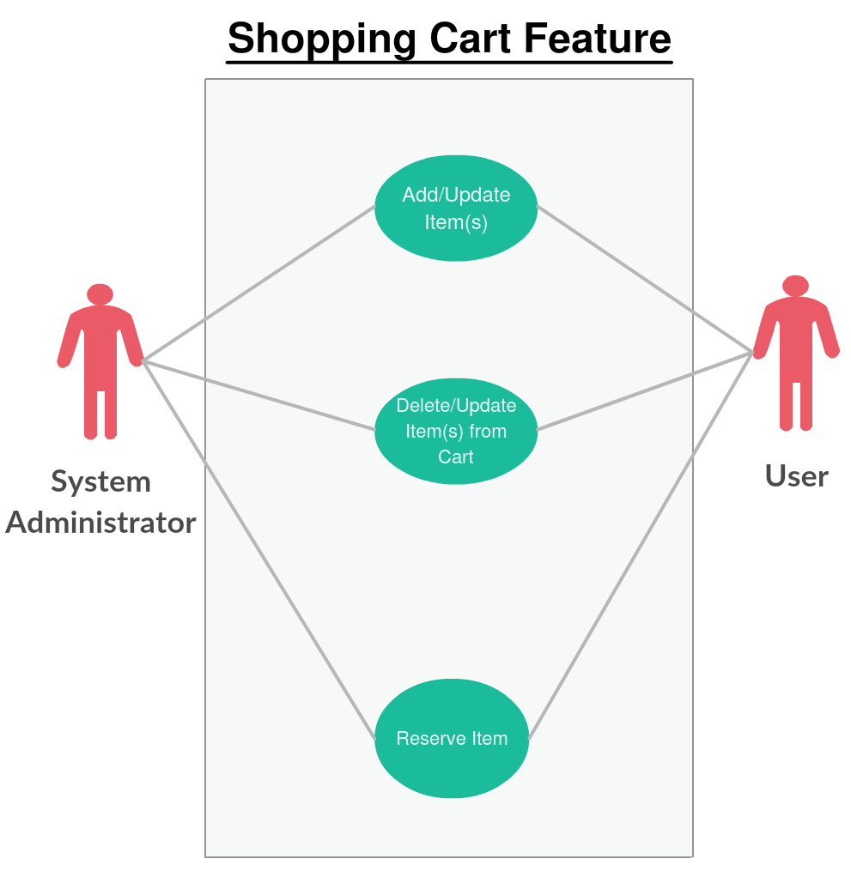

USE CASE #1 USER/Update Adds item to shopping cart

Any current customer should have a current account to access cart features to add/update items on the website. Any customer not logged into the site will be only able to see the products and not use any cart functions. The cart will allow the users to save items for future purchases and add items from their current shopping cart to checkout. Users may update items on cart page. Only an administrator will see any products in all customer’s cart. Customer’s may not see any other customer’s shopping cart.

The “shopping cart add/update function” use case contains the following basic steps:

1. IMS user logs into website.
2. IMS System validates user login information.
3. IMS user uses navigation bar to find product.
4. IMS user adds item to cart.
5. IMS System validates stock to ensure availability.
6. IMS user updates item(s)’s model/quantity/type in cart.
7. IMS System validates stock to ensure availability.
8. IMS user buys item located in the cart.
9. IMS System validates payment method.
10. IMS System validates stock to ensure availability.
11. IMS System updates stock availability.

USE CASE # 2: User Deletes/Updates item from shopping cart

Any current customer should have a current account to access cart features to delete/update items on the website. Any customer not logged into the site will be only able to see the products and not use any cart functions. The cart will allow users to delete/update items from their current shopping cart to checkout. Only an administrator will see any products in all customer’s cart. Customer’s may not see any other customer’s shopping cart.

The “shopping cart delete/update function” use case contains the following basic steps:

1. IMS user logs into website.
2. IMS System validates user login information.
3. IMS user clicks cart icon to access products in cart.
4. IMS user finds item in cart to delete and deletes it.
5. IMS System validates deletion of product from user’s cart.
6. IMS System updates stock availability.
7. IMS user updates item(s)’s model/quantity/type in cart.
8. IMS System validates stock to ensure availability

USE CASE #3: User reserves item in shopping cart

Any current customer should have a current account to access cart features to reserve items on the website. Any customer not logged into the site will be only able to see the products and not use any cart functions. The cart will allow the users to save items for a specific time allotted by the system and reserve items from their current shopping cart to checkout. Only an administrator will see any products in all customer’s cart. Customer’s may not see any other customer’s shopping cart.

The “shopping cart reserve function” use case contains the following basic steps:

1. IMS user logs into website.
2. IMS System validates user login information.
3. IMS user uses navigation bar to find product.
4. IMS user reserves item to cart.
5. IMS System validates stock to ensure availability.
6. IMS System checks real time.
7. IMS System deducts stock from availability.
8. IMS System starts timer of reserve time.

FEATURE: Product Catalog

**Team Member: Alex**

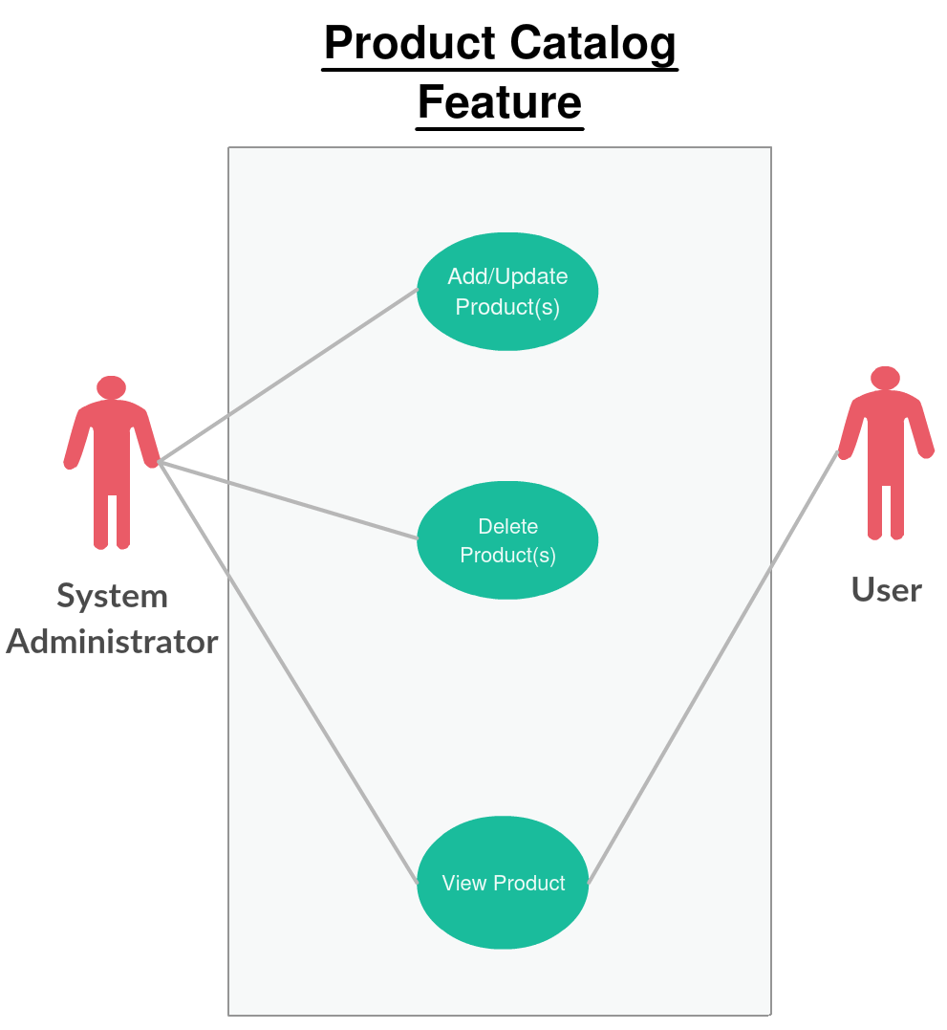

USE CASE #1 Add/Update Product

Any user can actively check products via the product catalog without having to login to the website. The product catalogs should be accessible to any user with a computer and internet connection on any browser of their choice. The user and the administrator will view separate product description pages since the administrator will add/update products accordingly.

The “Add/Update Product” use case contains the following basic steps:

1. IMS System Admin logs into admin panel.
2. IMS System validates System Admin login information.
3. IMS System Admin uses navigation bar to find product.
4. IMS System Admin Adds Product.
5. IMS System validates product submission.
6. IMS System Admin uses navigation bar to find product.
7. IMS System Admin Updates a Product.
8. IMS System validates product update.

USE CASE # 2: Delete Product

Any user can actively check products via the product catalog without having to login to the website. The product catalogs should be accessible to any user with a computer and internet connection on any browser of their choice. The user and the administrator will view separate product description pages since the administrator will delete products accordingly.

The “Delete Product” use case contains the following basic steps:

1. IMS System Admin logs into admin panel.
2. IMS System validates System Admin login information.
3. IMS System Admin uses navigation bar to find product.
4. IMS System Admin Deletes Product.
5. IMS System validates product submission.

USE CASE #3: Product View

Any user can actively check products via the product catalog without having to login to the website. The product catalogs should be accessible to any user with a computer and internet connection on any browser of their choice. The user and the administrator will view separate product description pages since the administrator will view products accordingly.

The “Product View” use case contains the following basic steps:

1. IMS user searches product and views OR uses categories to find product.

FEATURE: Reviews and Q&A

**Team Member: Aziz**

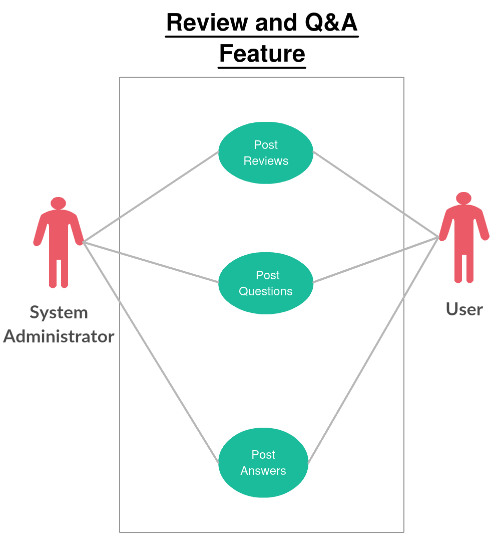

USE CASE #1 USER post reviews

Any user who has bought an item which has shipped successfully can post a review from the review link received in their email by the System. Viewing reviews requires no login to the website, but posting reviews requires the user to login and review link from email. Users do not have access to approving/disapproving their own or others user’s reviews. Only the administrator can approve and disapprove reviews.

The “Post Review” use case contains the following basic steps:

1. IMS user buys product.
2. IMS System sends review link to user after product has successfully shipped.
3. IMS user post review rating product via link provided by email.
4. IMS System Administrator approves/disapproves review.

USE CASE # 2: USER post questions

All users who are logged in the website are allowed to post questions in the Q&A section about the product they are viewing. Viewing questions about the product requires no login to the website, but posting questions requires the user to login. Users do not have access to approving/disapproving their own or others user’s questions. Only the administrator can approve and disapprove questions.

The “Post Questions” use case contains the following basic steps:

1. IMS user ask questions about product.
2. IMS System Administrator approves/disapproves question.

USE CASE #3: USER Post Answers

All users who are logged in the website are allowed to post answers to the questions in the Q&A section about the product they are viewing. Viewing questions and answers requires no login to the website, but posting answers to the question requires the user to login. Users do not have access to approving/disapproving their own or others user’s answers. Only the administrator can approve and disapprove answers.

The “Post Answers” use case contains the following basic steps:

1. IMS user answers question about product.
2. IMS System Administrator approves/disapproves answer to question.

SYSTEM REQUIREMENTS

FEATURE: Shopping Cart

USE CASE #1 USER Adds/updates item to shopping cart

The following table outlines the details of use case # 1: Adding Items To Cart

|  |  |
| --- | --- |
| Use Case ID:1 | Adding/Updating Items To/In Cart |
| Description | Any current customer should have a current account to access cart features to add/update items on the website. Any customer not logged into the site will be only able to see the products and not use any cart functions.  The cart will allow the users to save items for future purchases and add items from their current shopping cart to checkout.  Users may update items on cart page. Only an administrator will see any products in all customer’s cart. Customer’s may not see any other customer’s shopping cart. |
| Input | * User Clicks Add Item(s) to Cart * User Clicks up Update Quantity in Cart. * Product ID or SKU Number * Discount code |
| Output | * If adding an item is successful, system will return success message. * If transaction was successful, then the system will return a ” Thank You” message back to the user. If the transaction failed, the system will return the appropriate error message. |
| Preconditions | * If user tries to add item(s) to the cart, the database checks if item is available. * If user tries to update item(s) in cart, the database checks if item is available. * If user buys the item in the cart, the database checks if item is available. |
| Post Conditions | * If the item is in the database, the user can add/update the item into the cart. |
| Action | IMS System will validate the following rules before adding/updating item(s) to the cart:   * Validation of stock. * Decrement of stock when item is added to cart. System must make sure that item(s) does not fall below zero in database. * Update cart quantity when item(s) is added. * Confirmation to adding/updating item(s) to cart. |
| Frequency of Use | Frequent |

USE CASE # 2: Delete/update item from shopping cart

The following table outlines the “Delete Item From Shopping Cart” use case details:

|  |  |
| --- | --- |
| Use Case ID:2 | Delete/Update Item From Shopping Cart |
| Description | Any current customer should have a current account to access cart features to delete/update items on the website. Any customer not logged into the site will be only able to see the products and not use any cart functions.  The cart will allow users to delete/update items from their current shopping cart to checkout.  Only an administrator will see any products in all customer’s cart. Customer’s may not see any other customer’s shopping cart. |
| Input | * User Clicks Delete Item(s) in Cart * User Clicks to Update Quantity in Cart. * Product ID or SKU Number |
| Output | * If deleting an item is successful, system will return success message. |
| Pre-conditions | * Confirm if there is an item in the cart. |
| Post Conditions | * If item is in the cart, delete it. |
| Action | IMS System will validate the following rules before deleting/updating item(s) to the cart:   * Validation of stock. * Increment of stock when item is deleted from cart. System must make sure that item quantity in cart does not fall below zero. * Update cart quantity when item(s) is deleted. * Confirmation to deleting/updating item(s) to cart. |
| Frequency of Use | Frequent |

USE CASE #3: reserve item in shopping cart

The following table outlines the “Reserve Items In Shopping Cart” use case.

|  |  |
| --- | --- |
| Use Case ID:3 | Reserve Items In Shopping Cart |
| Description | Any current customer should have a current account to access cart features to reserve items on the website. Any customer not logged into the site will be only able to see the products and not use any cart functions.  The cart will allow the users to save items for a specific time allotted by the system and reserve items from their current shopping cart to checkout.  Only an administrator will see any products in all customer’s cart. Customer’s may not see any other customer’s shopping cart. |
| Input | * User Clicks Reserve Item(s) to Cart. * Product ID or SKU Number |
| Output | * If reserving an item is successful, system will return success message. * If reserving the item in the cart succeeds, the system will send a “Success” message, but if the reservation fails, the system will send back an “Error, no stock available” message. |
| Pre-conditions | * If user tries to reserve item(s) to the cart, the database checks if item is available. |
| Post Conditions | * The item(s) will be reserved and the quantity will be decremented in the database. |
| Action | IMS System will validate the following rules before reserving item to the cart:   * Validation of stock. * Decrement of stock when item is added to cart. System must make sure that item(s) does not fall below zero in database. * Update cart quantity when item(s) is added. * Confirmation to reserving item to cart. |
| Frequency of Use | Frequent |

FEATURE: Product Catalog

USE CASE #1 System Administrator adds/Updates product

The following table outlines the details of use case # 1: Add/Update Product(s)

|  |  |
| --- | --- |
| Use Case ID:1 | Add/Update Product(s) |
| Description | Any user can actively check products via the product catalog without having to login to the website. The product catalogs should be accessible to any user with a computer and internet connection on any browser of their choice.  The user and the administrator will view separate product description pages since the administrator will add/update products accordingly. |
| Input | * System Administrator adds/updates Product ID or SKU Number * System Administrator adds/updates general specification about product. |
| Output | * Successful message output upon adding/updating product(s). |
| Preconditions | * Check if product is not already in database/web page when adding product. * Check if product exist when updating product. * Check if the product specification is correct according to the product. |
| Post Conditions | * If product is not in database/web page then display product. * If product does exist then update product. * If the specification is correct, then display the product specification/description to the web page. |
| Action | IMS System/System Administrator will validate the following rules before adding/updating product(s) to the product catalog:   * System will confirm if adding/updating of product is completed. * System will confirm if System Administrator added/updated product information. * System is able to append adding products and returning confirmation message upon having actions completed. * System/System Administrator is able to add/update general specification of products and return confirmation message upon having actions completed. |
| Frequency of Use | Frequent |

USE CASE # 2: System Administrator deletes Product

The following table outlines the “Delete Product(s)” use case details:

|  |  |
| --- | --- |
| Use Case ID:2 | Delete Product(s) |
| Description | Any user can actively check products via the product catalog without having to login to the website. The product catalogs should be accessible to any user with a computer and internet connection on any browser of their choice.  The user and the administrator will view separate product description pages since the administrator will delete products accordingly. |
| Input | * System Administrator deletes Product ID or SKU Number * System Administrator deletes general specification about product. |
| Output | * Successful message output upon deletion of product or product information. |
| Pre-conditions | * Check if item is available in database/web page. |
| Post Conditions | * If item is available in database/web page, then delete it. |
| Action | IMS System/System Administrator will validate the following rules before deleting product(s) from the product catalog:   * System will confirm if deleting of product(s) is completed. * System will confirm if System Administrator deleted product information. * System/System Administrator is able to delete general specification of products and return confirmation message upon having actions completed. |
| Frequency of Use | Frequent |

USE CASE #3: User Views Product Catalog

The following table outlines the “User Views Product Catalog” use case.

|  |  |
| --- | --- |
| Use Case ID:3 | User Views Product Catalog |
| Description | Any user can actively check products via the product catalog without having to login to the website. The product catalogs should be accessible to any user with a computer and internet connection on any browser of their choice.  The user and the administrator will view separate product description pages since the administrator will view products accordingly. |
| Input | * N/A |
| Output | * Product information page. |
| Pre-conditions | * Product must be linked to correct web page. |
| Post Conditions | * If Product is linked to correct web page, then webpage will be displayed on site. |
| Actions | * N/A |
| Frequency of Use | Frequent |

FEATURE: Reviews and Q&A

USE CASE #1 USER post reviews

The following table outlines the details of use case # 1: User Post Reviews

|  |  |
| --- | --- |
| Use Case ID:1 | User Post Reviews |
| Description | Any user who has bought an item which has shipped successfully can post a review from the review link received in their email by the System. Viewing reviews requires no login to the website, but posting reviews requires the user to login and review link from email.  Users do not have access to approving/disapproving their own or others user’s reviews. Only the administrator can approve and disapprove reviews. |
| Input | User:   * Product ID or SKU Number * Content/Description of Review * Date of posting * Username * Stars Ranking of Product   System:   * Approve/Disapprove review. |
| Output | User:   * Post review returns successful message.   System:   * Approve/Disapprove review returns successful message. |
| Preconditions | * If user has bought item which has shipped successfully, than user can make review post. |
| Post Conditions | * User review post is accepted. |
| Action | IMS System/System Administrator will validate the following rules before approving Reviews:   * Dispatch email for Review after User’s Item has shipped successfully. * Approve/Disapprove review. |
| Frequency of Use | Infrequent |

USE CASE # 2: USER post questions

The following table outlines the “User Post Questions” use case details:

|  |  |
| --- | --- |
| Use Case ID:2 | User Post Questions |
| Description | All users who are logged in the website are allowed to post questions in the Q&A section about the product they are viewing. Viewing questions about the product requires no login to the website, but posting questions requires the user to login.  Users do not have access to approving/disapproving their own or others user’s questions. Only the administrator can approve and disapprove questions. |
| Input | User:   * Product ID or SKU Number * Content/Description of Question * Date of posting * Username   System:   * Approve/Disapprove Question. |
| Output | User:   * Posting question returns a successful message.   System:   * Approve/Disapprove question returns successful message. |
| Pre-conditions | * User’s question should be on topic about product. |
| Post Conditions | * User question is accepted. |
| Action | IMS System/System Administrator will validate the following rules before approving Questions:   * Approve/Disapprove Question about Product if Question is on-topic. |
| Frequency of Use | Infrequent |

USE CASE #3: USER Post Answers

The following table outlines the “User Post Answers”  use case.

|  |  |
| --- | --- |
| Use Case ID:3 | User Post Answers |
| Description | All users who are logged in the website are allowed to post answers to the questions in the Q&A section about the product they are viewing. Viewing questions and answers requires no login to the website, but posting answers to the question requires the user to login.  Users do not have access to approving/disapproving their own or others user’s answers. Only the administrator can approve and disapprove answers. |
| Input | User:   * Product ID or SKU Number * Content/Description of Answer to Question * Date of posting * Username   System:   * Approve/Disapprove Answer to Question. |
| Output | User:   * Posting answer returns a successful message.   System:   * Approve/Disapprove answer returns successful message. |
| Pre-conditions | * User’s answer should be on topic about product and be the correct answer. |
| Post Conditions | * User answer is accepted. |
| Action | IMS System/System Administrator will validate the following rules before approving Answers:   * Approve/Disapprove Answer about Product if Answer is on-topic for Question. |
| Frequency of Use | Infrequent |

SYSTEM MODELS

FEATURE: Shopping Cart

USE CASE #1 User Adds/Updates Item To Shopping Cart

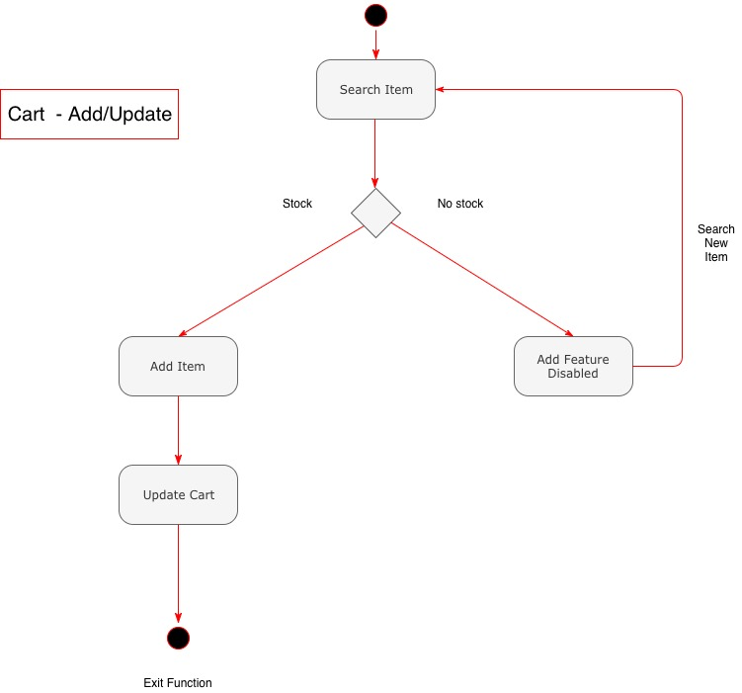

This diagram describes the process of adding an item into the cart. After the user has successfully logged in, the user can navigate or search items in the website. After the user has searched an item, he or she can add the item into the cart only if the item is in stock. Otherwise user will get a message that item is not in stock. User can also increment/decrement quantity of items in the cart.

USE CASE # 2: User Deletes/Updates Item From Shopping Cart

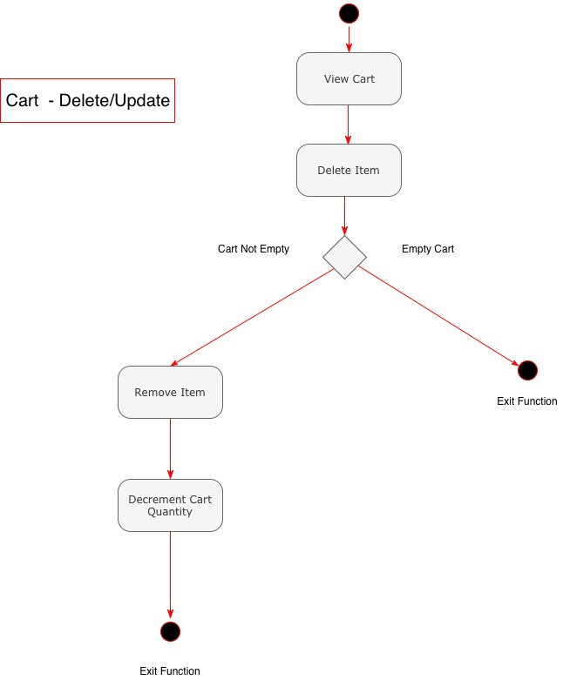

This diagram illustrates the process of deleting an item from the cart. After the user has logged into the website, the user has to first access the cart to find the item to delete. If the cart is already empty, no action needs to be taken. If the cart is not empty, then user needs to find the correct item to delete which will remove the item in question. User can also decrement quantity of items by updating in the cart.

USE CASE #3: User Reserves Item in Shopping Cart

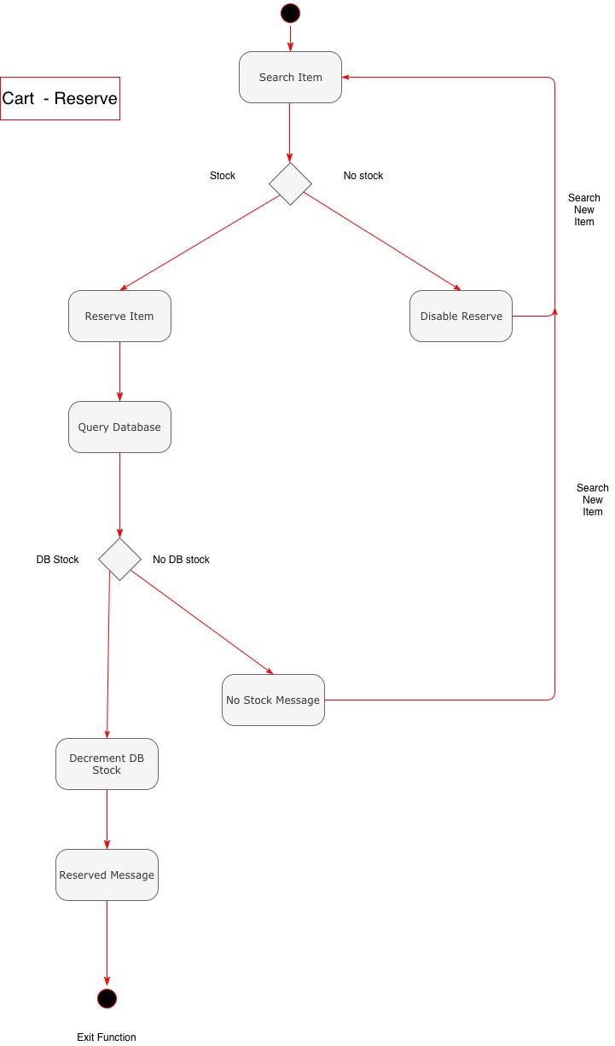

This diagram describes the process of reserving an item in the cart. After the user has logged into the website, the user will need to search for an item before reserving it. If the item in question has no stock, user will get a message confirming user cannot reserve because of no stock. If the item is in stock, then user will reserve the item. Before an item is reserved, the database once again checks if the item is truly in stock. If the item is in stock, the database will decrement the item stock by one and user will get a reserve message. If the item is not in stock in the database, the user will get a message confirming that item is not in stock.

FEATURE: Product Catalog

USE CASE #1: Add/update Product to the Catalog

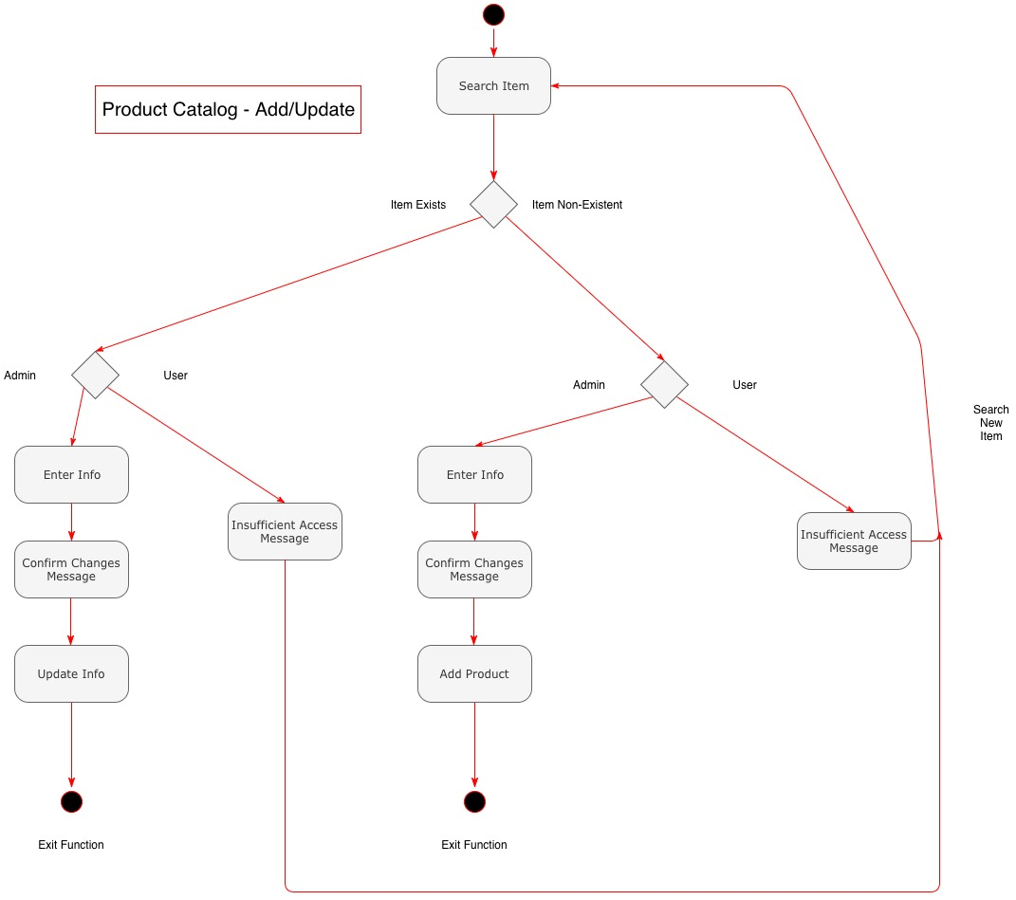

This diagram shows the addition of a product catalog along with updating the product.  From the system administrator’s point of view, if the administrator can search the product, then the product does not require to be added. If the product does not exist, an administrator will add the product information such as a picture or general specification for example and receive a confirmation message before adding the product. If the product requires updating, an administrator will require searching the item to access the product. Updating products will give the system administrator a confirmation message before updating the product. User does not partake in any addition of products.

USE CASE # 2: Delete Item from Product Catalog

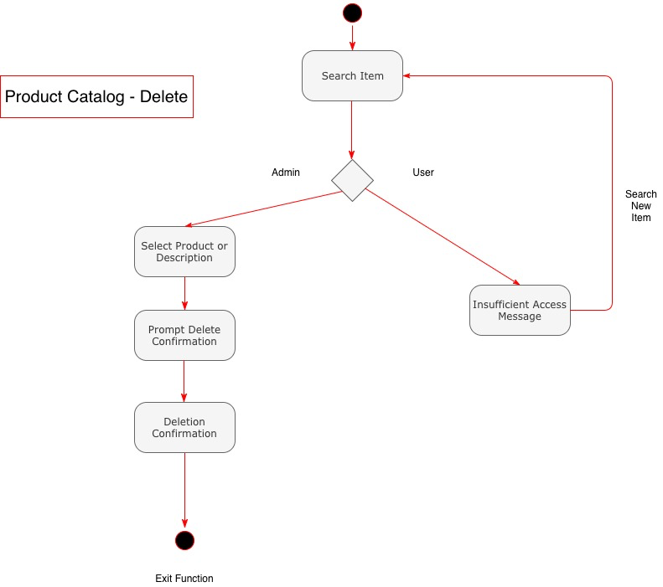

This diagram depicts a deletion of a product within the product catalog. The system administrator must first search an item to select it for deletion. Once the product is selected, it displays a delete confirmation message before deleting the product from the catalog. User cannot partake in the deletion function.

USE CASE #3: View Item in Product Catalog

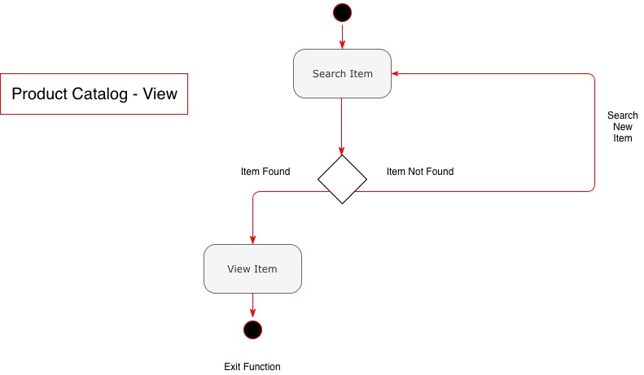

This diagram shows the process of viewing an item within the product catalog. The user or system administrator searches for an item. If it does not find the item, the user and administrator will have to search for an item again. If it finds then the item both the administrator or the user can view the item in the product catalog.

FEATURE: Reviews and Q&A

USE CASE #1: Product Reviews

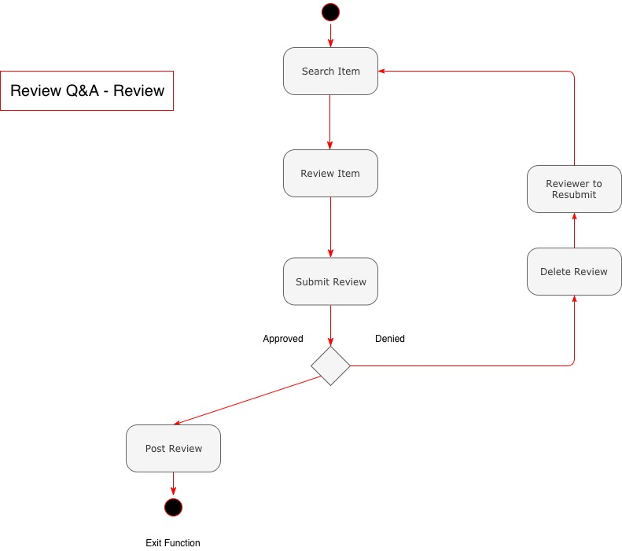

This diagram shows the process for adding a review to a product within the product catalog. First, the user searches the product catalog for the item to review, then inputs the review of the item.  After submitting the review, an administrator will approve or deny the review. If approved the system will post the review to the product catalog. If denied, it will delete the review and will advise the reviewer to change and resubmit the review.

USE CASE # 2: Questions for Q&A

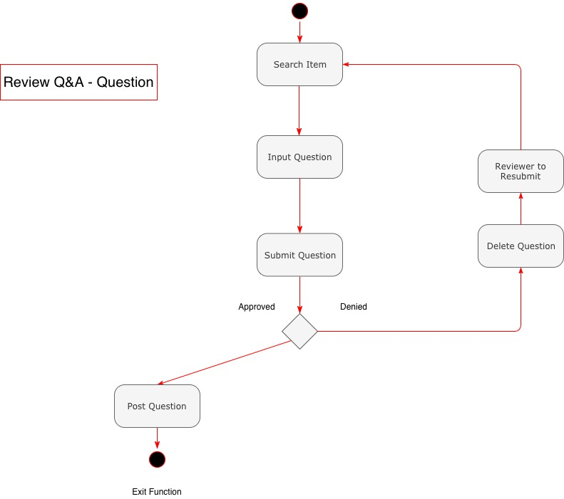

This diagram shows a question being submitted for a specific product within the product catalog. The user first searches for an item in the catalog. The user then submits a question about the product he or she searched. An administrator then approves or denies the submitted question. If approved, they will post the question to the product catalog page under the Q&A section. If denied, they will delete the question and they will advise the user to resubmit a new question.

USE CASE #3: Answers for Q&A

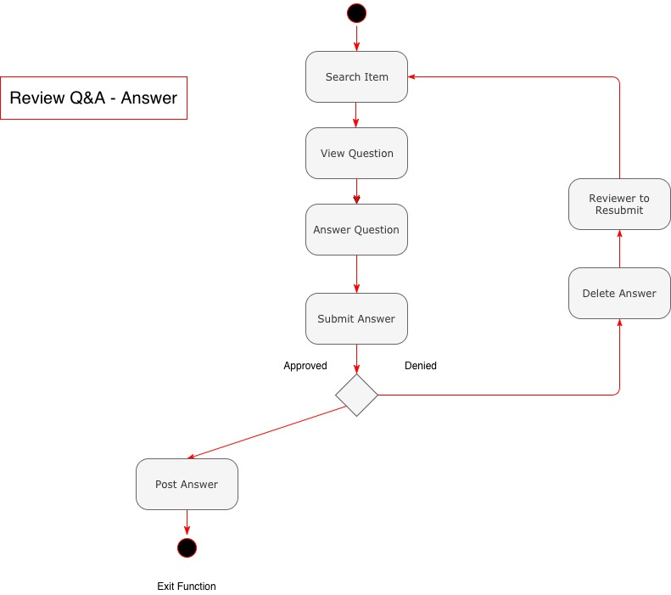

This diagram depicts an answer being submitted in response to a question within the product catalog. The user first searches for an item in the catalog. The user views the question(s) posted regarding the product he or she searched. The user answers one of the question(s) posted in the Q&A section. If the administrator approves the answer they will post it to the product catalog page under the Q&A section. If they deny it, they will delete the answer and they will advise the user to resubmit a new answer.

DOMAIN ANALYSIS – ALL FEATURE USE CASES

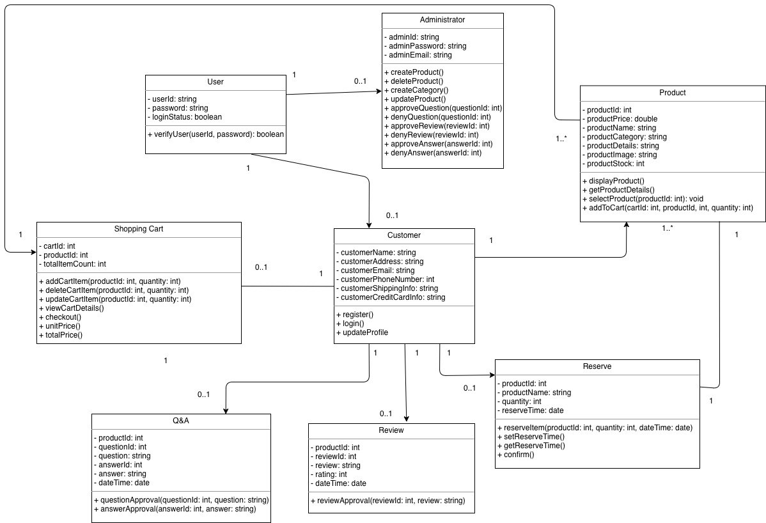

The class diagram above identifies the main entities for the Add/Update/Delete/Reserve Item in cart, Add/Update/Delete/View product in product catalog and post review/question/answer module.

The following entities have been identified:

**Shopping Cart**:

This entity is responsible for authenticating any product thus granting access to the system to query the database before adding, updating, deleting and reserving any product into the shopping cart.

**Product**:

This entity represents an entire product catalog with the system database dedicated to this entity to make sure the information given is correct.

**Review**:

This entity also is managed by the administrator entity. It has the ability to manage user entities reviews.

**Q&A**:

This entity is responsible for managing question and answers which are supervised by the administrator entity.

NON-FUNCTIONAL REQUIREMENTS

*The Computer Retail Shop should be online 24 hours a day, without downtime.*

*Cryptographical techniques will be applied to all transactions, passwords and payment methods.*

*Keep transaction logs*

Scheduled backups will occur every day at midnight.

*Compatibility with mobile and tablet platforms.*

*Compatibility with 1080p, 1440p and 4k resolutions*

APPENDIX

*Database - An organized collection of data that is stored, accessed, modified and managed through a computer system.*

*Flow chart - Represents a flow of data to visually present the process of the software.*

*UML (Unified modeling language) - Provides the visual design of the software system.*

*Use case - Shows the interaction between the user and system for the software product.*

INDEX

*Constraints, 10*

*Feature, 10, 14, 16, 22, 26, 35*

*IMS System, 12, 13*

*Input, 18, 20, 23*

*Output, 18, 20, 22*

*Product function, 9*

*System administrator, 16*

*System requirement, 18*

*UML, 41*

*Use case, 11, 12, 13, 16, 17, 18, 22, 26, 30*

*User, 16*

*User requirement, 10*